INTRODUCTION
CV Mitra Techno has established in 2003, we have developed an engineering business as our principal business activities of the company.
At February 2008 CV Mitra Techno was change become PT Techno Triireka. PT Techno Triireka has developed trading business (Sales Division) and engineering business (Engineering Division) as our principal business activities of the company

The sales division is focusing on providing the industrial machines and the tools used at the factory site of the automotive industry.
The engineering division is focusing on machining, fabrication, design for a special machineries
on automotive company.

In any course of business, we examine all customers request throughly and respond straight forward to accomplish the Corporate Philosophy triad, "Customer Satisfaction", "Quality Improvement” and "Originality and Ingenuity".
Likewise, we consider it is important to propose our customers one step further such as eco- friendly products.

We will continue to be the company that provides reliability and satisfaction to all customers. It is our mission to become ”Your Trully Global Partner" by responding to various needs of
customer.

COMPANY PROFILE

Company Name | PT TECHNO TRIIREKA
Head Office | Jl. Duta Boulevard L10, Duta Harapan, Harapan Baru,  Bekasi Utara  Kota Bekasi, Jawa Barat – Indonesia 17123 Telp : +62 (021) 8887 6969  Fax : +62 (021) 8887 2340  Web site : www.techno-triireka.co.id  e-mail : sales@techno-triireka.co.id
Workshop I (Machining &  Fabrication) | Kawasan Industri Delta Silicon 3 Jl. Trembesi No 11 Cikarang  Kabupaten Bekasi – Jawa Barat
Workshop II  (Manufacturing, Regrinding Cutting Tools, Precision Part & Wire Cut) | Sentra Onderdil 2 Blok FB No.22, 65, 66  Kota Harapan Indah Bekasi – Jawa Barat 17131
President  Director | Muhammad Dawam
Establish | 2008
Description Of  Main Bussiness | Engineering & Trading, machines and tools, Manufacturing and supplying mechanic & electronic  components, Conveyor system, Import and Export
NPWP | 02.744.242.5.413.000
PKP | 02.744.242.5.413.000
BANK | Bank Mandiri

DESCRIPTION OF BUSSINES
ENGINEERING DIVISION

Activity | We design, fabricates, machining & precision parts and machineries base from our customers request  on various industries
PT. ASTRA DAIHATSU MOTOR | JIG / FIXTURE :  - OIL PAN HOLE DIE CASTING  - RING PISTON INSERTER ASSY  - ENGINE & TRANSMISSION ASSY  - ENGINE NUMBERING  - CYLINDERHEAD COVER MACHINING  - ENGINE BELT TENSION  - STICK PKB TESTER  - JIG DOOR GLASS  - ETC.  SPECIAL MACHINE  - CLUTH HOUSHING WASHING M/C  - ENGINE NUMBERING M/C  - KNUCKLE ASSY M/C  - ETC  ASSEMBLY S/A MACHINE  - STEERING COLUMN S/A TABLE  - BRAKE TUBE S/A TABLE  - ACTUATOR S/A TABLE  - PEDAL S/A TABLE  - PBS LIFTER  NUT RUNNER ASSEMBLY MACHINE  - TYRE WHEEL HUB  - FRONT SUSPENSION MEMBER  - REAR SUSPENSION  - DRIVE SHAFT  - DRIVE PLATE
PT. ASTRA HONDA MOTOR | JIG / FIXTURE  - CYLINDERCOMP MACHINING  - AWING ARM WELDING ASSY  - FIRRING / ENGINE TEST SPECIAL MACHINE  - CYLINDERCOMP LEAKTESTER M/C  - CYLINDERHEAD LEAKTESTER M/C  - FUEL TANK LEAKTESTER M/C  - FUEL TANK WATER LEAK M/C  - HUB REAR/FRONT PRESS BEARING M/C  - SWING ARM PRESS BUSHING M/C  - HUB FRONT MULTI DRILL/TAP M/C  - FLANGE MULTI DRILL/TAP M/C
PT. MESIN ISUZU INDONESIA | SPECIAL MACHINE  - JIG CYLINDERBLOCK MACHINING  - JIG TRANSMISSION MACHINING  - HUB ROTARY WASHING M/C

PT. SHOWA MFG INDONESIA | SPECIAL MACHINE  - AUTO DRILLING M/C  - UNDERBRACKET PRESS FIT M/C
PT. AKASHI WAHANA INDONESIA | SPECIAL MACHINE  - HOUSHING LEAKTESTER M/C  - REAR MISSION PRESS BUSHING M/C  - JIG HOUSHING PRESS BUSHING M/C
PT. MUSASHI AUTO PARTS | SPECIAL MACHINE  - BOX ROTARY WASHING M/C  - AUTO SUPPLY CONVEYOR  - AUTO INPECTION M/C
PT. KEIHIN INDONESIA | SPEWCIAL MACHINE  - CARBURATOR BODY VK/NCV DRIL/TAP M/C
PT. PROGRESS DIE CASTING | JIG / FIXTURE :  - AUTO DRYING CONVEYOR  - BRACKET LEVER HONDA MACHINING  - BRACKET YAMAHA MACHINING  - CATRIDGE EPSON MACHINING  - WET DUST COLLECTOR  - IPER FLATNESS INSPECTION
PT. TRI DHARMA WISESA | SPECIAL MACHINE  - MASTER CYLINDER 03J WASHING M/C  - MASTER CYLINDER 4US WASHING M/C  - BODYCALIPER CRV WASHING M/C  - BODYCALIPER C55 WASHING M/C  - BODYCALIPER 4US WASHING M/C
PT. INTI GANDA PERDANA GROUP | SPECIAL MACHINE  - REAR HOUSHING ASSY LEAKTESTER  - KNUCKEL PRESS BUSHING M/C  - AXLE HEATING MACHING
PT. MEKAR ARMADA JAYA | SPECIAL MACHINE  - DHAISA TRANSPORT CAR 20 TON
PT. GENERAL MOTOR INDONESIA MANUFACTURING | SPECIAL MACHINE  - TRIMMING ASSEMBLY LINE MANIPULATOR  - DOOR OFF  - DOOR ON  - COCKPIT  - SEAT  - FUEL TANK  - TYRE LOAD  - PREPARATION LINE  - BEARING PRESS MACHINE  - HUB PRESS MACHINE  - FRONT VERTICAL ASSY  - FRONT HORIZONTAL  - SPRING COMPRESSION  - ROTOR FLATNESS CHECK  - SHIELD ASSEMBLY TABLE  - RUN OUT ASSY JIG

WORKSHOP I FACILITIES
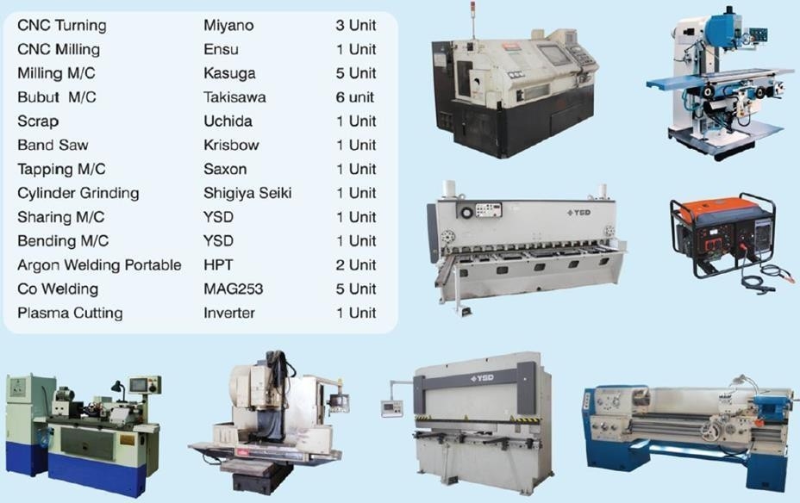

WORKSHOP II FACILITIES

MEASUREMENT FACILITIES
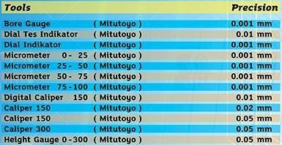

MACHINE FACILITIES
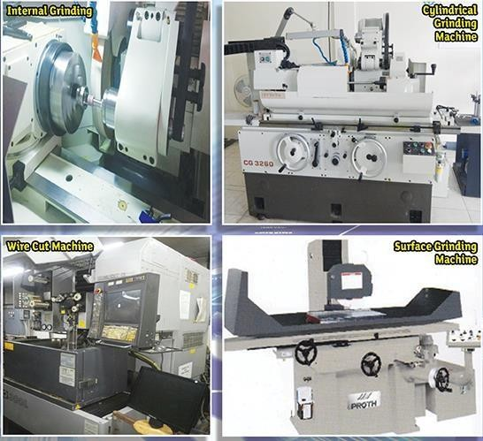
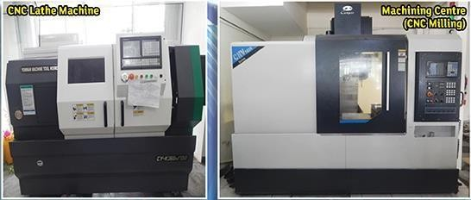

TRADING DIVISION

ACTIVITIES &  Authorized Distributor | We supply various machines as Authorize Distributor, tools, equipments and etc. in manufacturing :  - OHMI (Bit & Socket Driver)  - LUVATA (Welding Part Consumable)  - WETZEL (Spray Booth Filter & Environment Filter)  - DeLED & Dr. LED (LED Light & Solar Panel System)  - BIBIELLE (Abrasive)  - HANGCHA & NOBLIFT (Traction Equipment & Spare Part)  - MODULAR ASSEMBLY TECHNOLOGY (Alumunium Pipe Racking System)  - POSILIFT (Lifting & Positioning Equipment)  - SANKYO FUJI STAR (Abrasive & Polishing)  - MEECH (Static Control Sytem)  - SANYO (Nut Runner Equipment)  - MYTORQ (Impact & Screw Driver)
PHILOSOPHY | - Direct hearing of customer voices. Careful learning about use and environment. Figuring out perfect solutions.  - Strong support from our supplier for Improvement & Development of products.  - We understand manufacturing process and we answer to every kind of small request with full efforts
OUR CUSTOMERS | ASTRA DAIHATSU MOTOR – ASSY PLANT ASTRA DAIHATSU MOTOR – CASTING PLANT ASTRA DAIHATSU MOTOR – ENGINE PLANT ASTRA DAIHATSU MOTOR – STAMPING PLANT  ASTRA DAIHATSU MOTOR – KARAWANG ASSY PLANT ASTRA HONDA MOTOR  HITACHI ASTEMO BEKASI POWERTRAIN SYSTEMS SUZUKI INDOMOBIL MOTOR  UNIPRES  FUJI TECHNICA INDONESIA FRINA LESTARI NUSANTARA GAYA MOTOR  ASTRA AUTOPARTS (NUSA METAL) CIKARANG PERKASA MANUFACTURING ICHIKOH  NISSHO  INTI GANDA PERDANA  INTI PANTJA PRESS INDUSTRI ISUZU ASTRA MOTOR INDONESIA MEKAR ARMADA JAYA  ISUZU INDONESIA MUSHASHI AUTOPARTS PROGRESS DIE CASTING PARAMOUNT BED SHOWA INDONESIA  TRI DHARMA WISESA  GENERAL MOTOR INDONESIA MANUFACTURING PTPN X SURABAYA  CHEIL JEDANG INDONESIA PASURUAN SMELTING GRESIK

BRAND AND PRODUCTS

Machine Tools | Milling & Lathe Machine, Press Machine, Bandshaw, Keyence,  Kitagawa, Nikken, Yukiwa, Rego-fix
Power Tools | Sanyo Nut Runner, Panasonic Power Tools, Giken Nut Runner, Yutani, Fuji, Compact, Uryu, Nitto Kohki, Makita, Meiji Air Compressor, Orion, Pukanishi, Hitachi, Bosch, Mytorq
Work Tools | Ohmi, Vessel, Nabeya, Asahi Tool, Hozan Tool, Lobster, Maeda Metal Industri, Super Tool, Fujiya
Measurement Tools | Mitutoyo, Ojiyas, Tonichi, Tokyo Seimitsu, Kanetec, Niigata Seimitsu, Obishi, Ohnishi, Yamato Scientific, A&D, Nakamura Mfg,  Kodama
Whetstone and Fasteners | Heiwa Technica, Yanase, Minitor, Nippon Resibon, NR, Fuji Grinding Wheel, Sanco Industry
Abbrasives | Bibielle, Fuji, 3M, Sankyo, Yanase, Minimo, Garryson
Cutting Tools | Hozan, Nicotec, Okazaki, Yamawa, Asahi Diamond, Amada, Muraki
Power Trains | Tsubaki, THK, Nissei, Miki Pulley, NTN, Oriental Motor, NSK, Daido Metal, Bando, Chemical, Dalton, Oghura.
Hydraulics & Pneumatics | SMC, CKD, Vogel Japan, Riken, Kuroda, Howa Machinery, Yuken Kogyo, Horiuchi, Daikin Industries, Tooki Kogyo, Nihon Pisco
Plumbing Equipment & Control Instrument | Terada Pump, Ebara, Torishima Pump, Kitz, Ihara Science, Junkosha, Aoi, Nihon Oisco, CK Metal, Asahi diamond
Welding Consumable & Equipment | Luvata, XWWelding, Tokinarc.  (Captip, Adapter GNA, Adapter Shank, Kickless Cable, Aid Cable, Holder, Shunt Cable, etc.)
LED Lamp and Solar Panel | De LED, GEPVS Energy, eogled, Hitachi
Forklift, Towing and Handling Equipment | Hangcha, Noblift, SIE
Auto Guides Vehicle  (AGV) | OKAGV, TechnoAGV
Manipulator and rail | Knight Rail, Armtec, Posilift
Logistic System | AIOI Picking Lamp, LeanPick
Safety Equipment & Clean Room | Toyosafety, Bobstar, Radians, MCR, Unico, Moldec, ESCO, Hozan, Maytec, Innovex, Momban
Alumunium Profile | MODULAR ASSEMBLY TECHNOLOGY (Modular Assembly Sytem, Modular Conveyor Sytem, Machine Guard System, Stair & Platform  System, Tubular Framing System)
Filtering Part | Wetzel Technologies (Painting Booth Filter &Environment), CP Filter, Phospating Filter, GAF Filter Etc.

OUR AUTHORIZED LETTER
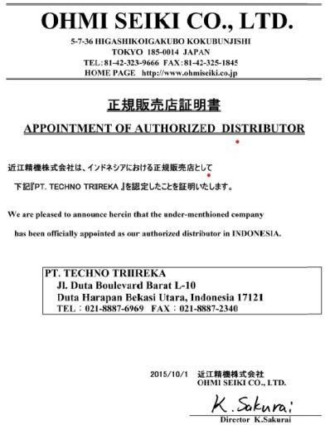
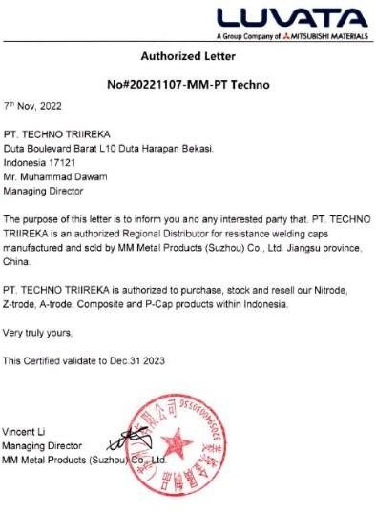
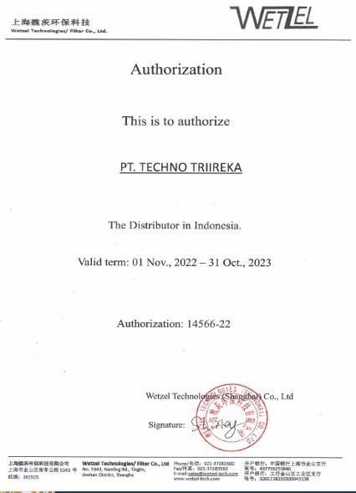
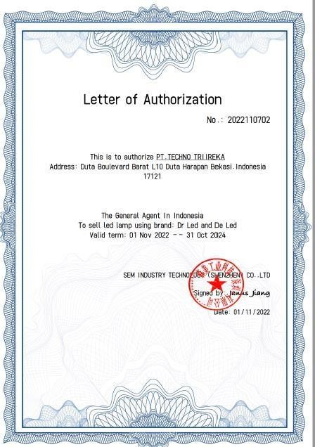
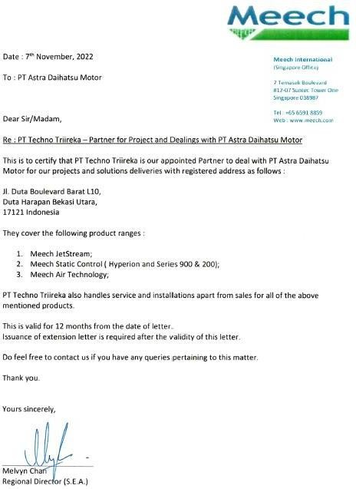
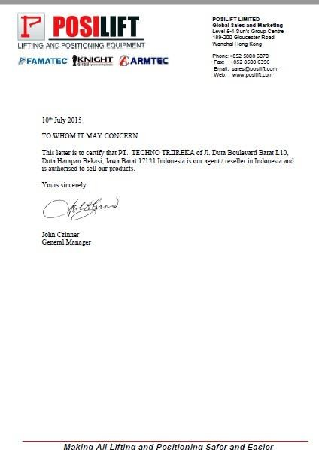
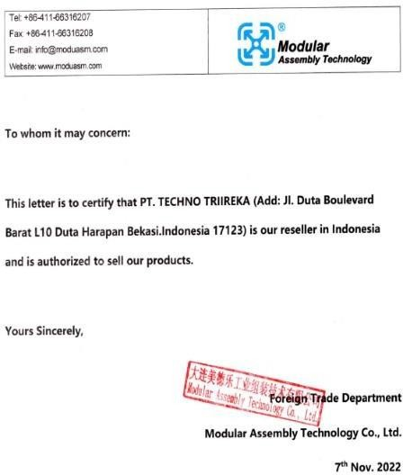
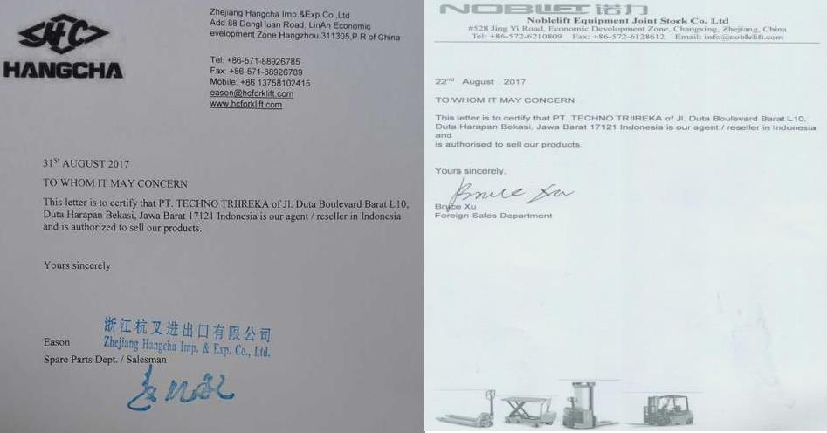

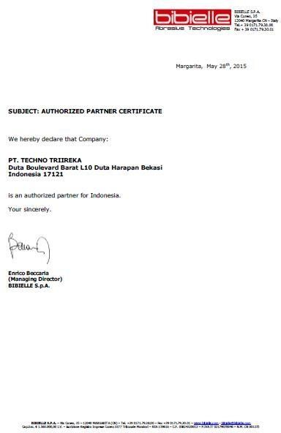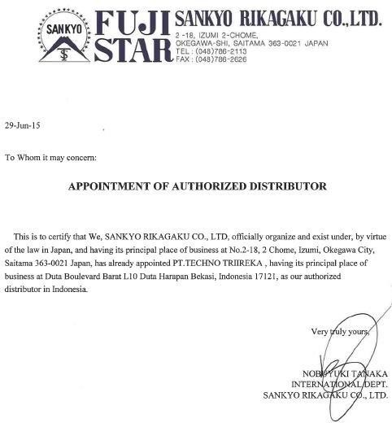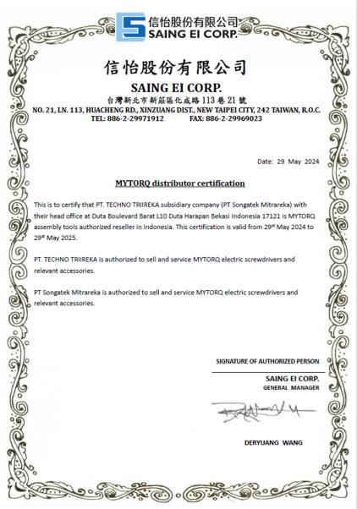

OUR PRODUCT & PROJECT
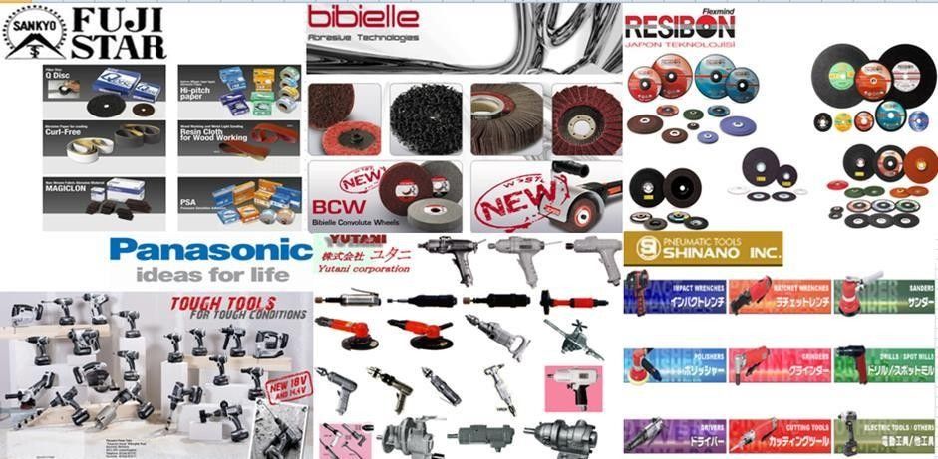
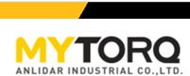
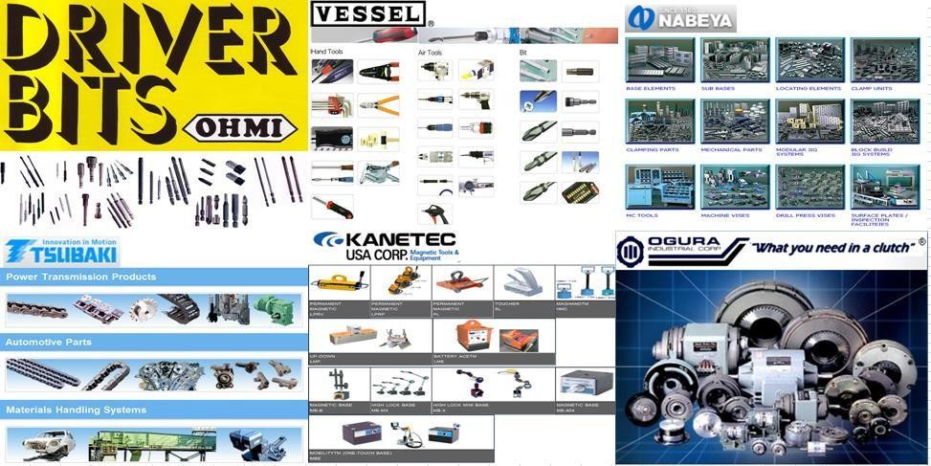

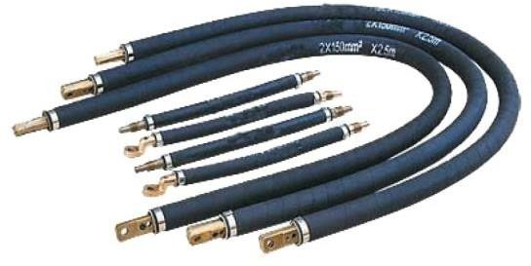
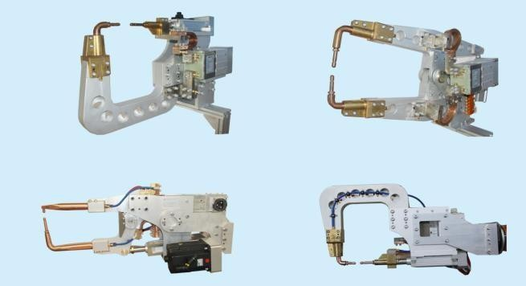
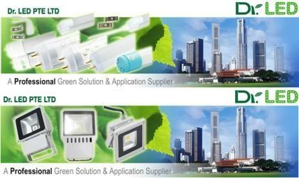
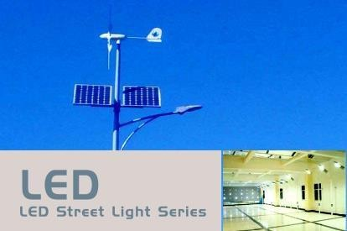
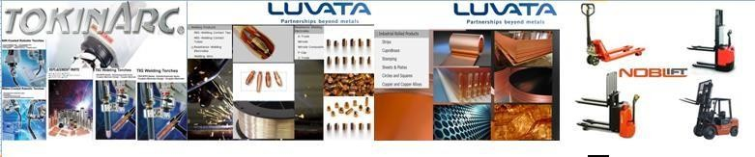
- WELDING PART (CAPTIP, SHANK, GNA, KICKLESS, AID, ARM GUN, Etc.)

  - NUT RUNNER (AC SPINDLE, CABLE & BATTERY MODEL)
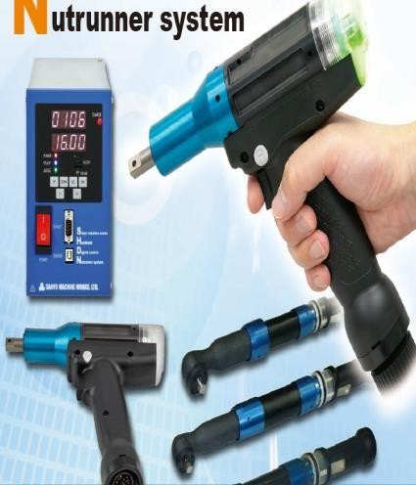
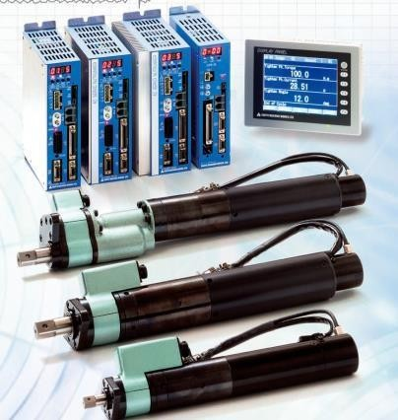
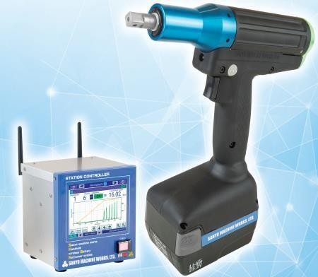

  - ASSEMBLY MACHINE MANIPULATOR
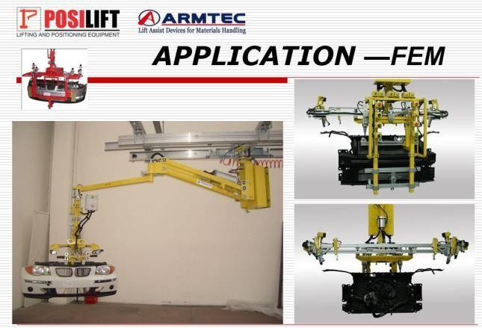
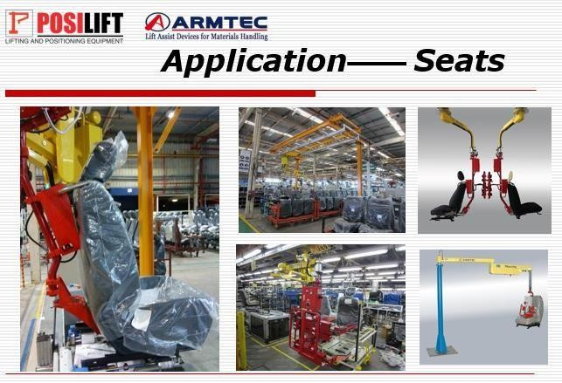

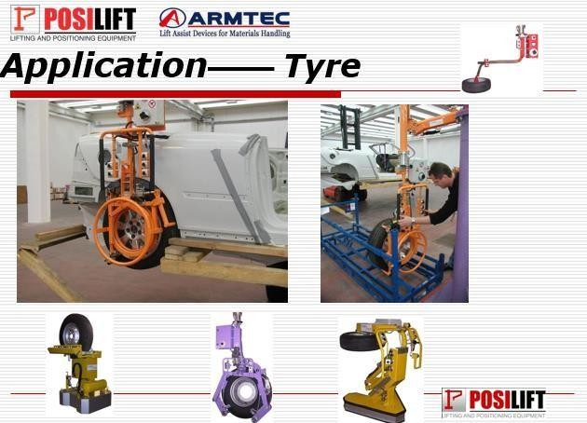
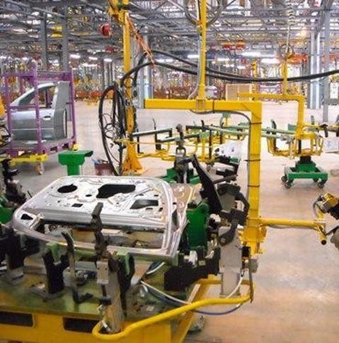
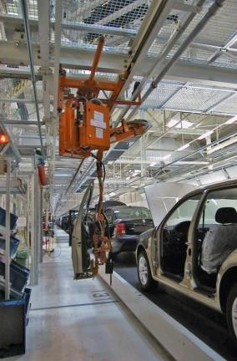

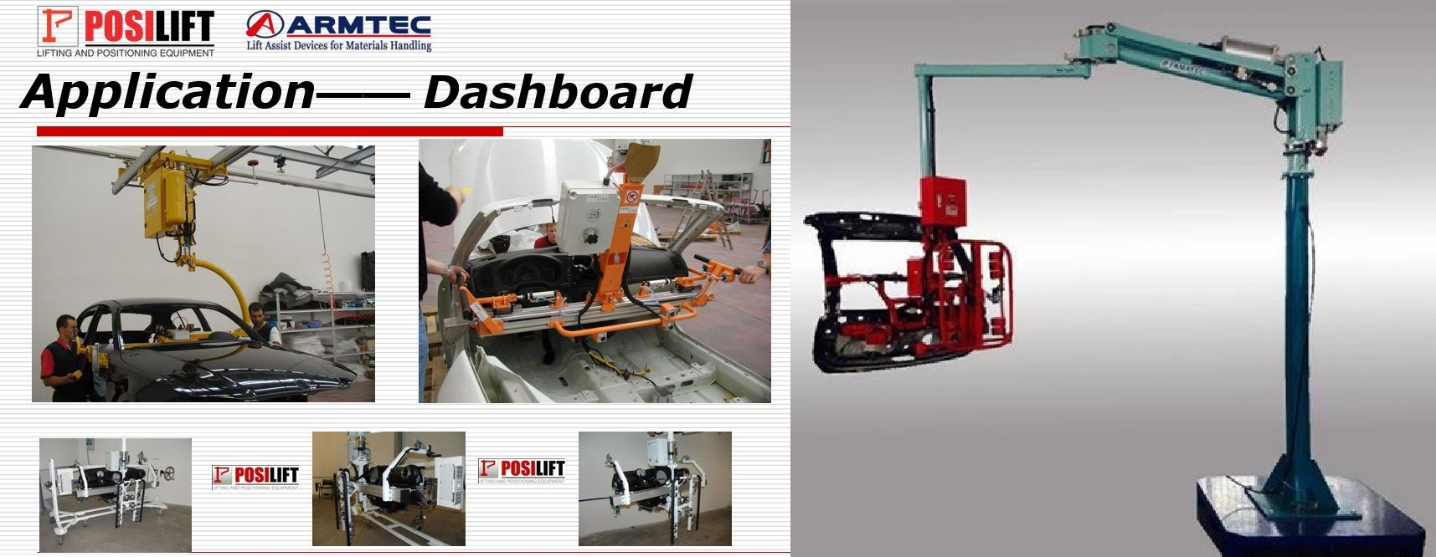

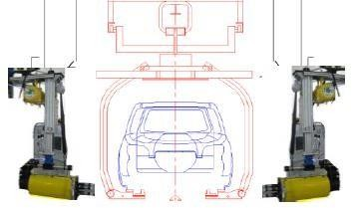
  - TYRE WHEEL HUB NUT RUNNER MACHINE

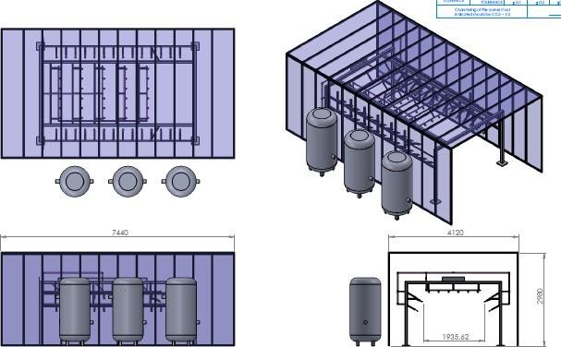
  - CAR LEAK TEST MACHINE

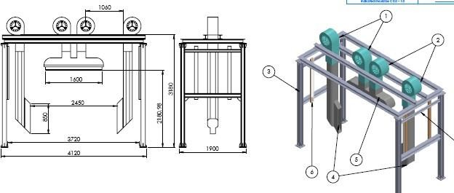

  - AGV (Automatic Guide Vehicle)
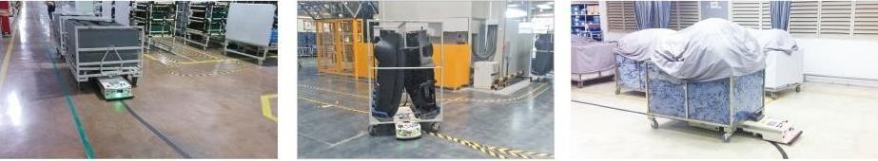

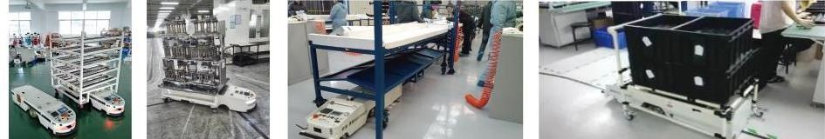

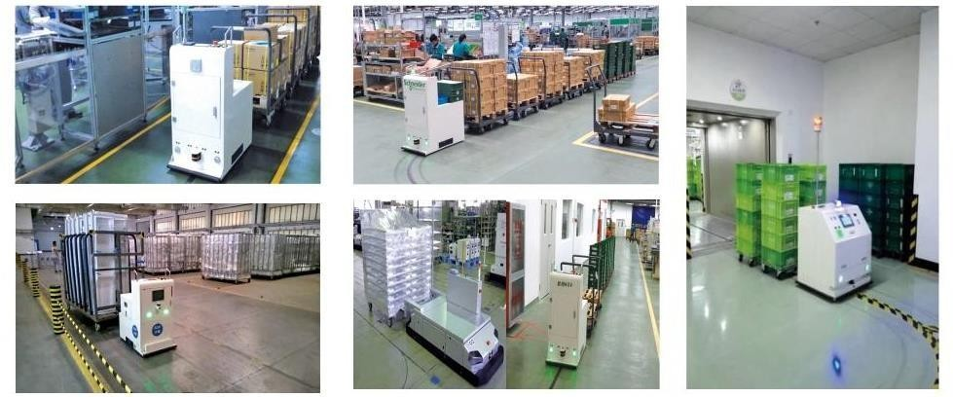

- ALUMUNIUM PROFILE (Pipe Racking, Conveyor System & Partition)
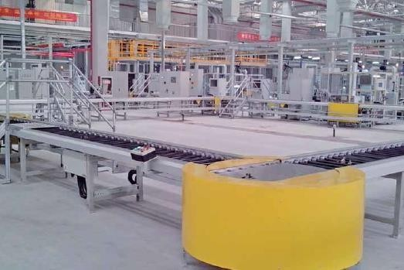
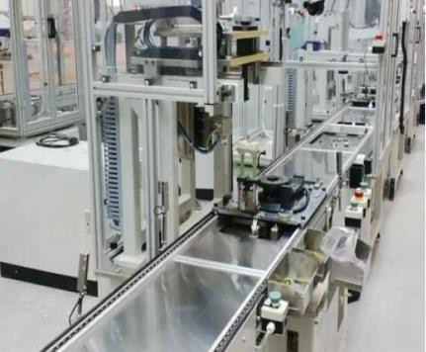

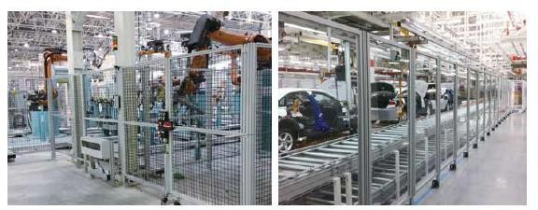

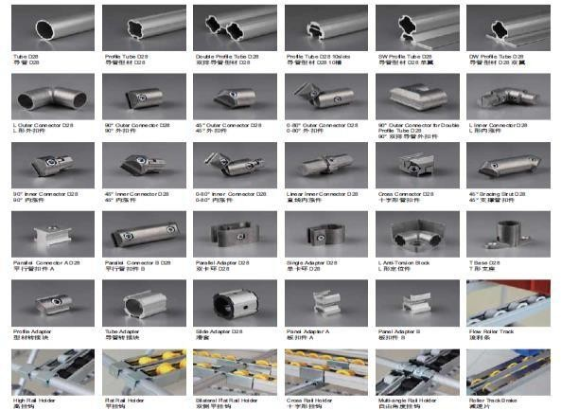
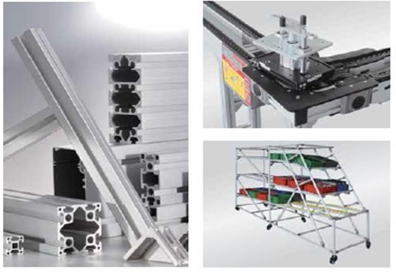

- CLEAN ROOM EQUIPMENT
